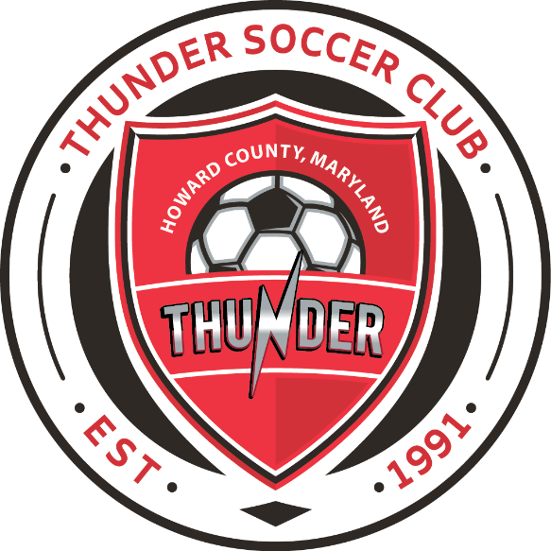

**David Jang**

[davidjang0530@gmail.com](mailto:davidjang0530@gmail.com)

**443-202-3613**

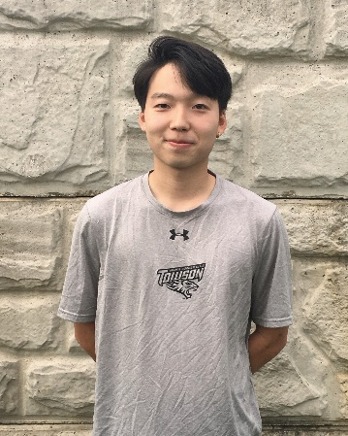David grew up in South Korea, but after moving to the United States in 2011 he graduated from Centennial High School where he played soccer all four years. He then attended Howard Community College winning the NJCAA Region XX title and advancing to the National Championship with the team. David is working to complete his degree at Towson University where he is majoring in Sports Management while also working as an assistant coach for the Howard Community College men’s soccer team.

**Playing Experience:**

* Centennial Hill High School Soccer: 2012-2014
* Howard Community College Men’s Soccer: 2017-2018

**Coaching Experience:**

* Assistant Coach—Howard Community College Men’s Soccer: 2020